Renju lesson on February 21, 2002

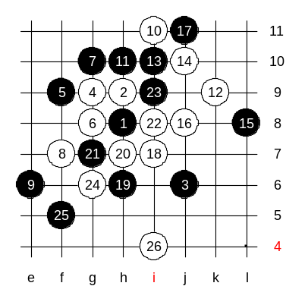
Hello everyone! Welcome to Online Renju Class. The first question today, is d13 good for white or black? Most of you answered white. Very well. As you remember, the last lesson was pretty exciting. Did anyone of you find sure win after class? Renjuhelper knows. Let him show now. Good forsaken, he shows the win here. Too easy. How did we all miss it before?! :)

Now, we will take a look at lower 7th move g7.
What is white’s tactics here? I give you a hint. “There is no maybe. White has only one choice. Otherwise inevitable loss”.
White will play in similar way with i12 opening. Look at the 12 stones on the board – similar with i12, isn’t it? In i12 opening, black has only one block. Where? Yes, d6 only. Here comes the big difference: If the j6 stone was at i6, then it would be a black big advantage and likely win. In our case, when stone is at j6, white wins.
The stone at j6 has no defensive power, compared to i6.
Where does white play now. It’s a good question. In traditional i12 opening style, white would play e8, but we must double check whether e8 is suitable in d13 opening.
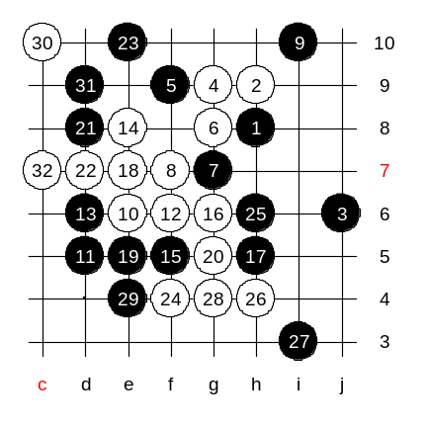
For example, g6 would lose. Shall we try traditional e8 and see what happens? Move 15-f5 is the only move. Now what? How to take advantage of the distance of j6 stone? Note that in i12 opening the 15-f5 was sufficient defense for black. But here we must prove white win somehow.
Ok, we begin with 16-g6.
Some of you suggest 22-e10. Why?? Do not forget the simple rule, we never play a four unless we really have to. Why do we need to hurry to e10? If we just play d7, black cannot play c7 anyway because of 3x3 at e9, and if black stops at e10, then we win as on diagram.
So, we proved white win in this variant. This 5th move is dead, right?

Another 5th move now. Ready all? Let’s go! 5-i9. The 6th move is obvious.
Now, black has several interesting blocks. Moves g6 and h10 are the strongest black moves. We play h10 first.
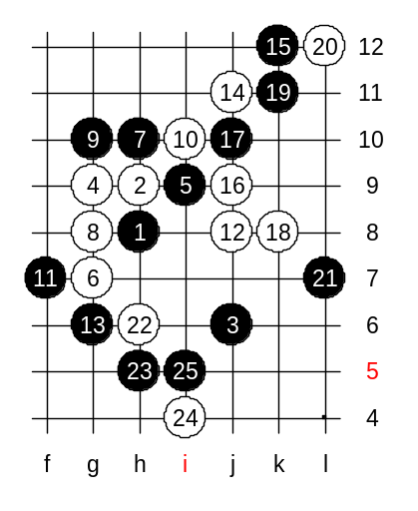
All the following moves are quite forced, therefore this variant is easy to learn. White needs h6 point, but we cannot play too early there because of black’s e8, f9. Therefore, we first have to set control for h11 point. Ok? We begin with j11 and j9. Then k8. Black’s k11 avoids immediate loss. Now, point h11 is under the control, and we can go h6 freely. Right? Black cannot attack with e8 and f9 anymore.
And now, regardless of black’s defense, white should win . Which black defense move you want to try out as a test? Yes, I agree h5 is good.
What we see now? What the theory ends, then the trouble begins.
We might need to take deeper look here.
We might even need to change the theory here, and overwrite the old one.

Next week we will still study d13. If white wins, then we end d13 next week, otherwise we will continue. I am sure white has a better plan than in the variant we ended up with.
We will continue with off-lesson analysis now right after this lesson. Who wants to join? Welcome!

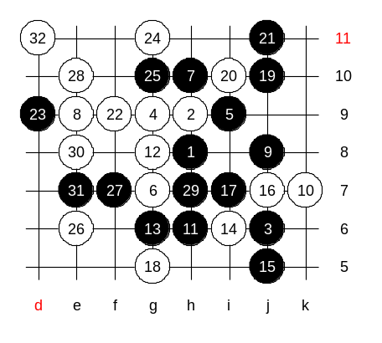
Off-lesson analysis:
Note that off-lesson analysis is just a quick tryout. It does not mean any of the variants shown here should be right or wrong. This analysis will just open up some ideas. That’s all.

Aggressive 8th move creates a big chaos.

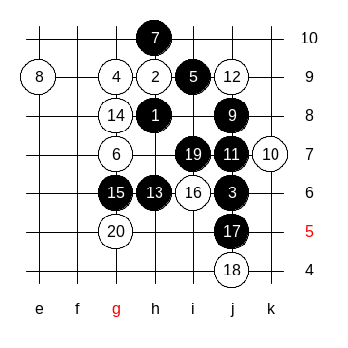

Unclear position.

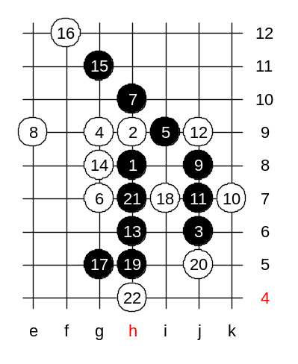

Seems like no win.

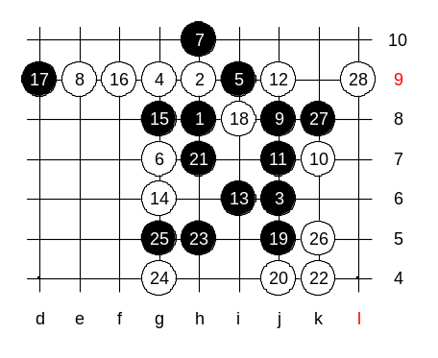

Becomes even more complicated.

